**Normalization Rule**

Normalization rules are divided into the following normal forms:

1. First Normal Form
2. Second Normal Form
3. Third Normal Form
4. BCNF
5. Fourth Normal Form

**First Normal Form (1NF)**

For a table to be in the First Normal Form, it should follow the following 4 rules:

1. It should only have single(atomic) valued attributes/columns.
2. Values stored in a column should be of the same domain
3. All the columns in a table should have unique names.
4. And the order in which data is stored, does not matter.

In the next tutorial, we will discuss about the [**First Normal Form**](https://www.studytonight.com/dbms/first-normal-form.php) in details.

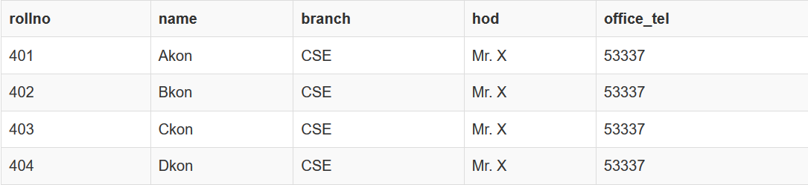

**Second Normal Form (2NF)**

For a table to be in the Second Normal Form,

1. It should be in the First Normal form.
2. And, it should not have Partial Dependency.

To understand what is Partial Dependency and how to normalize a table to 2nd normal for, jump to the [**Second Normal Form**](https://www.studytonight.com/dbms/second-normal-form.php) tutorial.

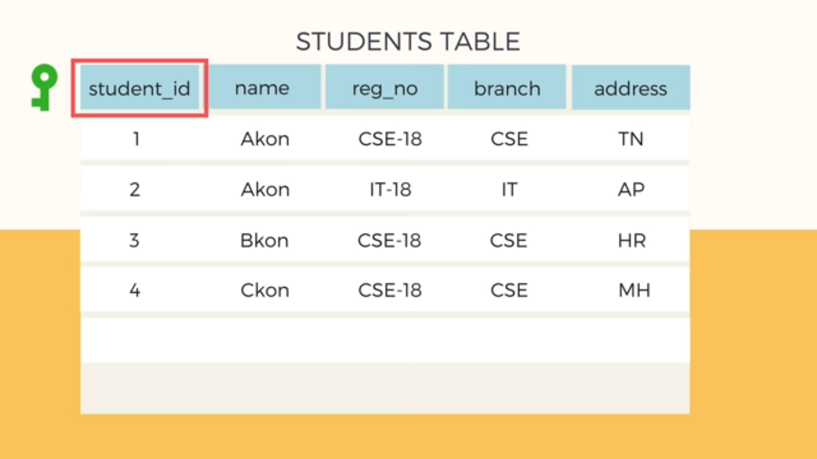

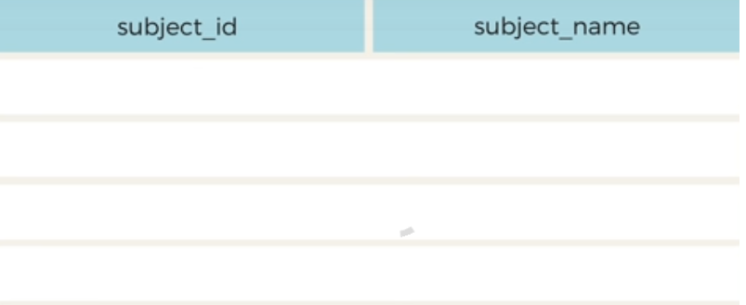

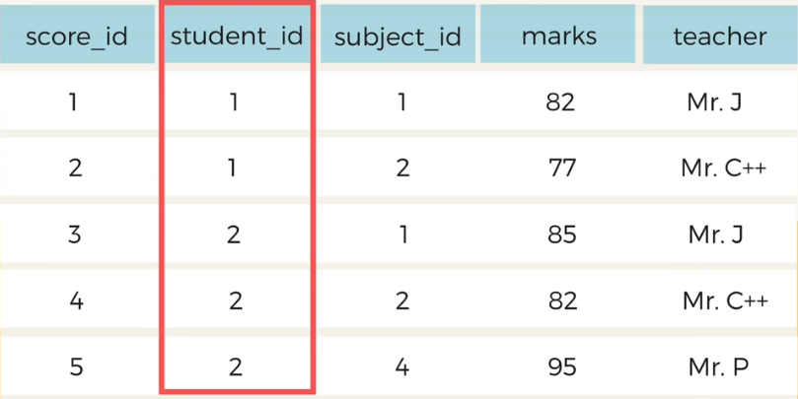

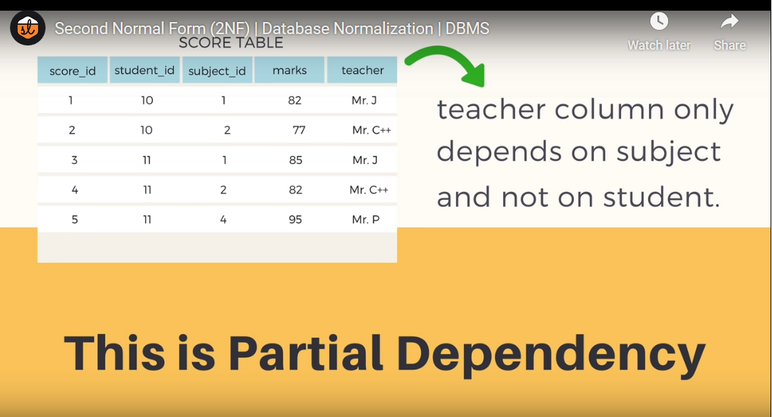

**SOLUTION**

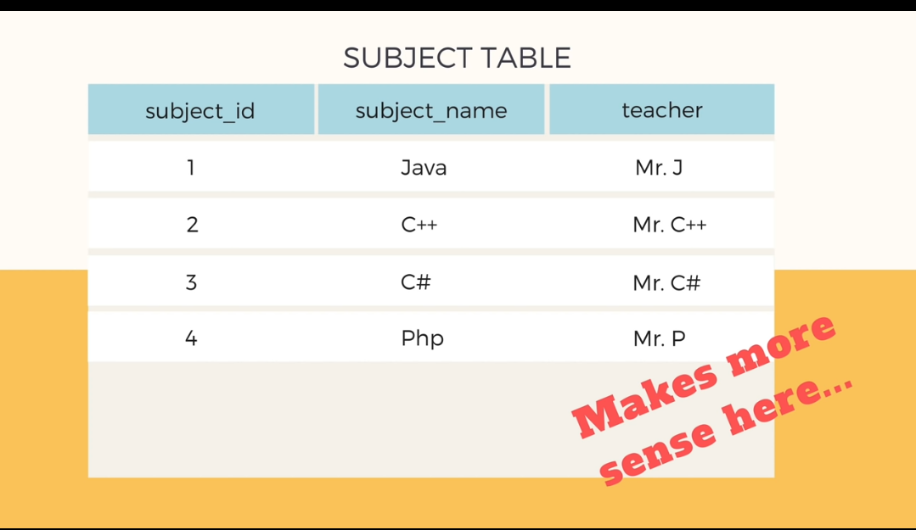

**OR**

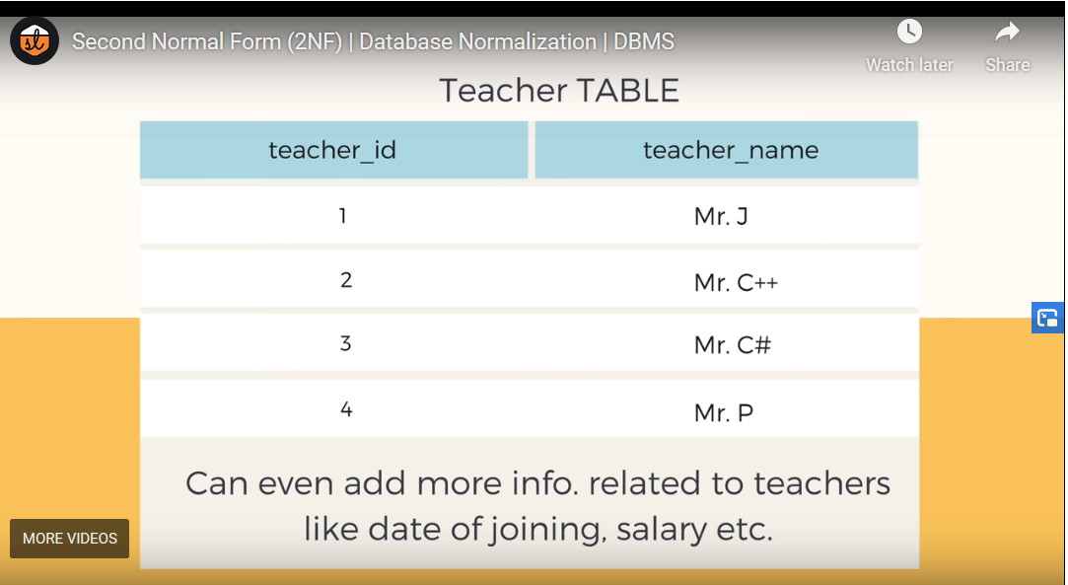

**Third Normal Form (3NF)**

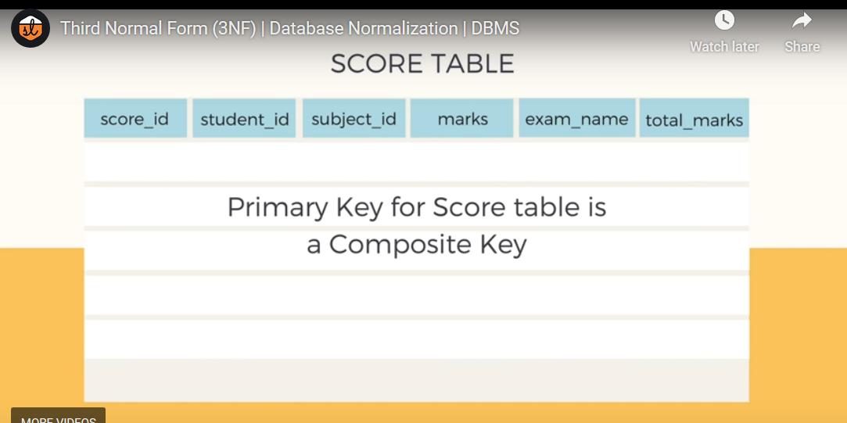

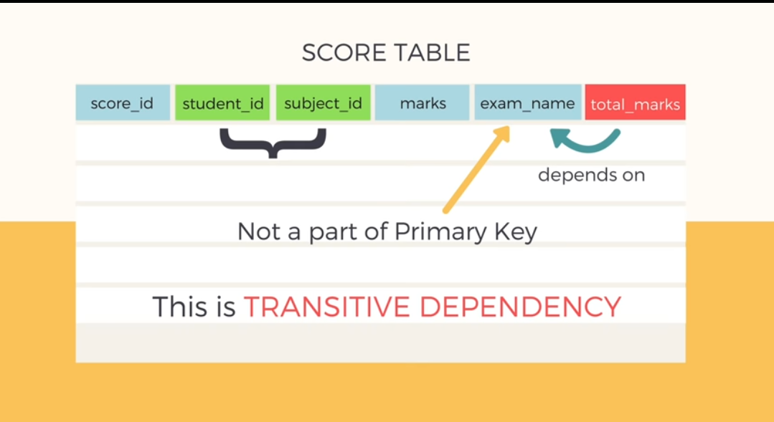

**SOLUTION**

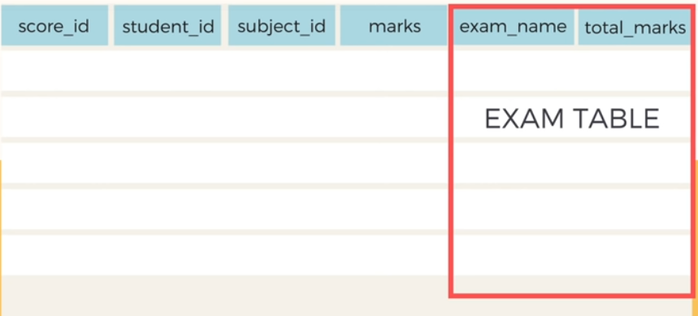

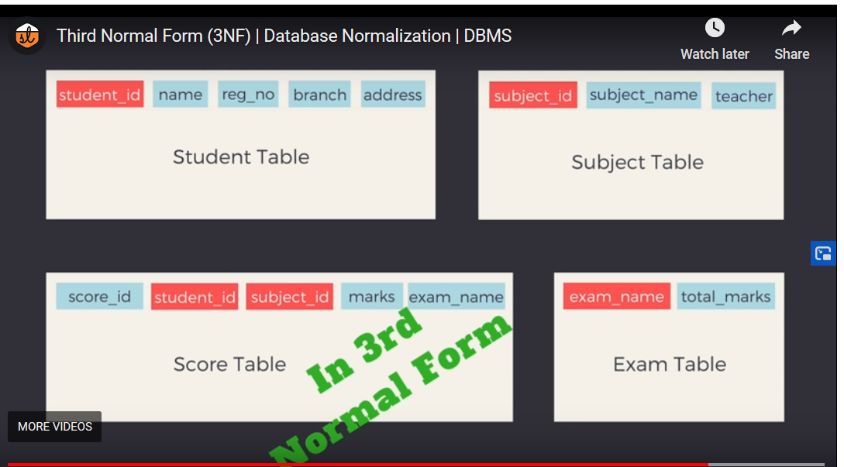

A table is said to be in the Third Normal Form when,

1. It is in the Second Normal form.
2. And, it doesn't have Transitive Dependency.

Here is the [**Third Normal Form**](https://www.studytonight.com/dbms/third-normal-form.php) tutorial. But we suggest you to first study about the second normal form and then head over to the third normal form.

**Boyce and Codd Normal Form (BCNF)**

**Boyce and Codd Normal Form** is a higher version of the Third Normal form. This form deals with certain type of anomaly that is not handled by 3NF. A 3NF table which does not have multiple overlapping candidate keys is said to be in BCNF. For a table to be in BCNF, following conditions must be satisfied:

* R must be in 3rd Normal Form
* and, for each functional dependency ( X → Y ), X should be a super Key.

To learn about BCNF in detail with a very easy to understand example, head to [**Boye-Codd Normal Form**](https://www.studytonight.com/dbms/boyce-codd-normal-form.php) tutorial.

Non Prime Attribute depending upon Prime Attribute

Non Prime Attribute depending upon Part of Prime Attribute

Non Prime Attribute depending upon Non Prime Attribute

HOW ABOUT

PRIME Attribute DEPENDING UPON NON PRIME ATTRIBUTE?

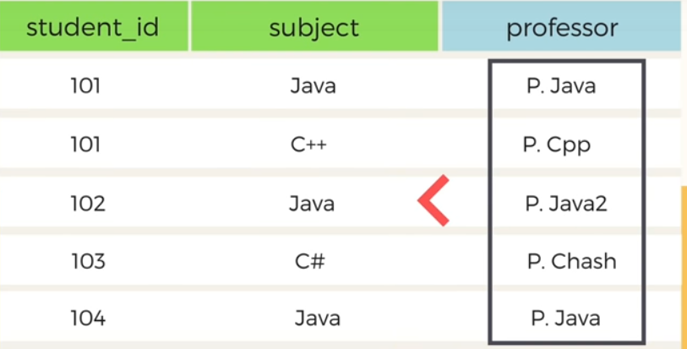

ABOVE TABLE IS IN 1 NF, 2 NF & 3 NF

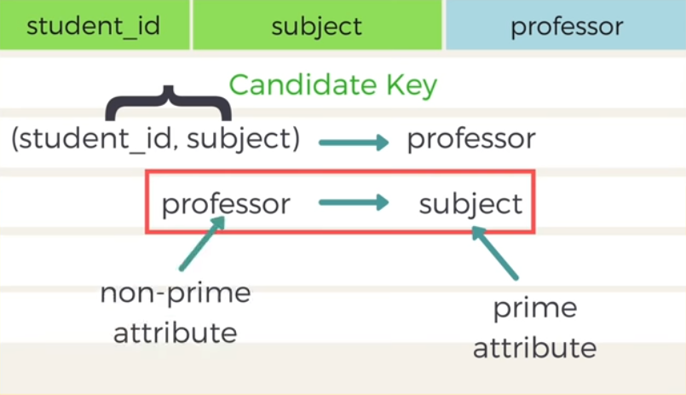

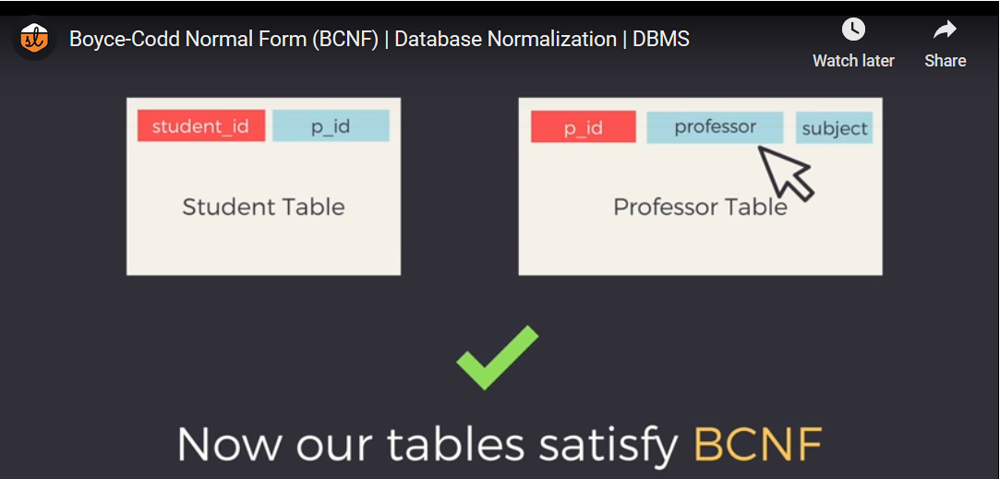

**Fourth Normal Form (4NF)**

A table is said to be in the Fourth Normal Form when,

1. It is in the Boyce-Codd Normal Form.
2. And, it doesn't have Multi-Valued Dependency.

EXAMPLE

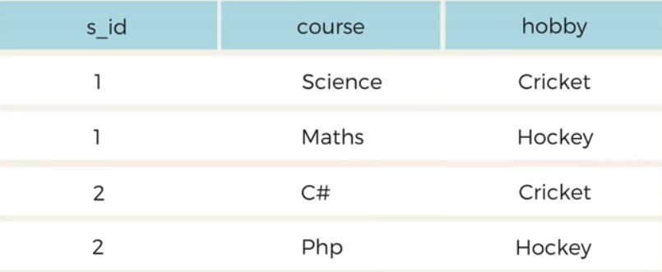

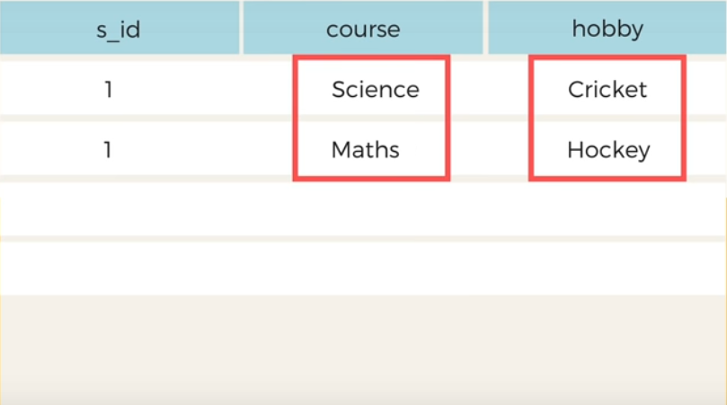

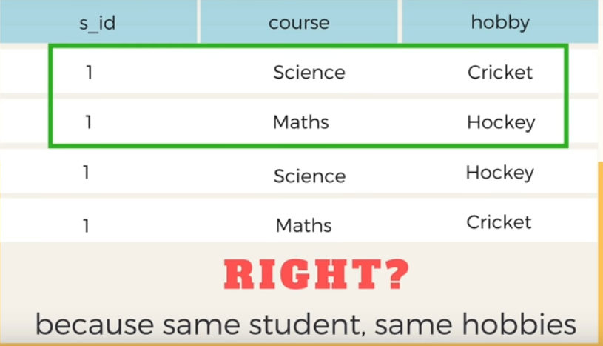

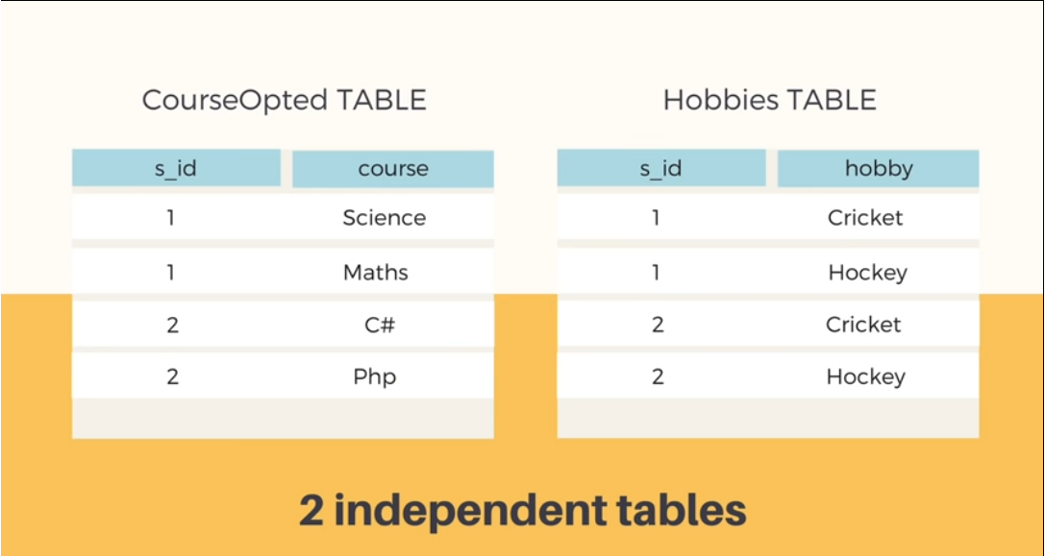

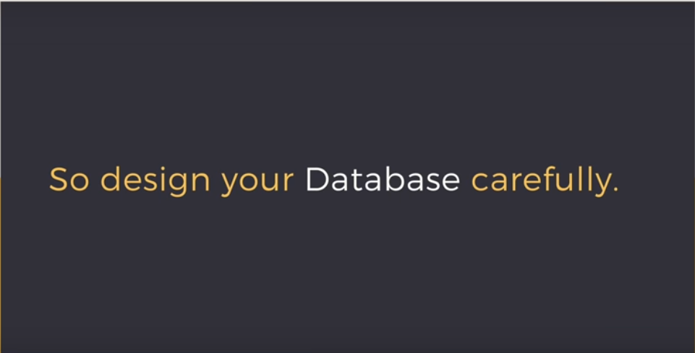

Here is the [**Fourth Normal Form**](https://www.studytonight.com/dbms/fourth-normal-form.php) tutorial. But we suggest you to understand other normal forms before you head over to the fourth normal form.

============================